Scalar Waves and the Human Möbius Coil System

Excerpts from the book: "The Heart of Health; the Principles of Physical Health and Vitality," by Stephen Linsteadt, NHD, CNC
Upcoming Workshops »

Contemporary cell research is now based on the principles of quantum physics that shows the world as being created out of energy. Researchers have now demonstrated that our cells' membranes contain special proteins called Intergral Membrane Proteins (IMPs) that respond to energy signals from the external and internal environment. These are important findings because they acknowledge that biological behavior can be controlled by "invisible" energy forces, which include thought.[1]
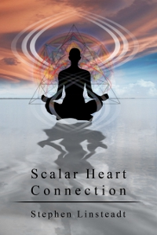
When we shut off our internal mind-talk and concentrate our attention through prayer, meditation or contemplation, we tune ourselves into this subtle, spiritual, quantum-level energy matrix. When this energy is allowed to transfer to our DNA (without interruption from negative attitudes), it affects the molecular and cellular levels that drive all our physical metabolic processes. This is why we have the ability to heal ourselves through prayer, meditation or conscious intention.
We are all connected to each other and to the energy source that makes up the universe. We are totally inter-dependent. Our body, our brain, our consciousness are inextricably joined with other matter in the universe. Every atom and molecule within us depends on the rest of the universe. Our brain and other parts of our neural physiology are interconnected by this unseen communication network which coordinates and regulates behavior of certain parts of the body.[2] The body, therefore, can be seen as a dense medium holding the real essence of who we are - Divine energy. We are interconnected outward expressions of this Divine energy. This interconnection is all-pervasive and instantaneous. The manifestation of this energy comes from the 'empty' vacuum, known as the quantum vacuum, which is actually 'packed full' of God's creative energy in a stable state. This all-pervading energy is sometimes referred to as a universal scalar wave, which is a form of electrostatic energy that has the potential to create but is currently without physical manifestation. Potential is only manifested when we provide the frequency information through our thoughts and intentions of what it is we want to create. This is the concept of 'mind over matter.' Our potential is unlimited and therefore what we are capable of creating is also unlimited.
The energetic link that we all share explains how our intentions, thoughts and prayers can travel to a sick friend and connect with their mind and consciousness. It also explains why every action is followed by a reaction. Everything that happens to one particle or to a collection of particles, as in our being, affects every other particle. All of our actions and thoughts have ramifications throughout the universe.
The body is also constantly generating these universal scalar waves. Scalar waves are produced when two electromagnetic waves of the same frequency are exactly out of phase (opposite to each other) and the amplitudes subtract and cancel or destroy each other. The result is not exactly an annihilation of magnetic fields but a transformation of energy back into a scalar wave. This scalar field has reverted back to a vacuum state of potentiality. Scalar waves can be created by wrapping electrical wires around a figure eight in the shape of a möbius coil. When an electric current flows through the wires in opposite directions, the opposing electromagnetic fields from the two wires cancel each other and create a scalar wave.
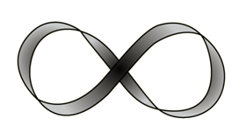
The DNA antenna in our cells' energy production centers (mitochondria) assumes the shape of what is called a super-coil.[3] Supercoil DNA look like a series of möbius coils. These möbius supercoil DNA are hypothetically able to generate scalar waves. Most cells in the body contain thousands of these möbius supercoils, which are generating scalar waves throughout the cell and throughout the body.
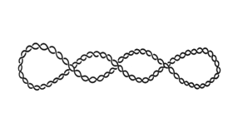
There is another möbius coil configuration found within the vascular system. The continuous flow of blood through the arterial system--which runs next to the venous system but in opposite directions--contains möbius coil properties. The circulation of blood throughout the body resembles the figure-eight shape of the möbius coil.
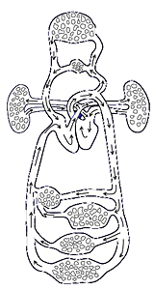
Within the vascular möbius coil there are subsets of the figure eight along the major capillary networks. These major capillary networks are associated with primary organs and are related to the endocrine glands and correspond to the chakra energy centers.
The electrical activity of the heart muscle sets up its electromagnetic field, the strongest field of the body. It is at the heart that the center of the vascular möbius coil is found: an intersection of venous blood passing through the right atrium, overlapping aortic blood coming through the left atrium.
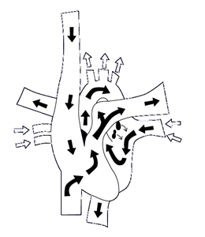
The möbius coil intersection occurs just in front of the lungs, which contain a huge web-like network of capillary connections. This capillary network acts as a battery for the storage of scalar waves.
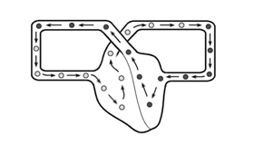
Scalar waves generated in the body protect us from the negative effects of solar radiation and other environmental electromagnetic stresses by constantly producing a neutral field capable of deflecting these harmful non-bio-energetically compatible frequencies. Scalar waves generated in the body also provide an energetic communication system that connects all cells. This energy contains the power of the universe and has unlimited potential.
In the scalar vacuum state this energy is susceptible to our thoughts and feelings. Our cells react to environmental signals as well as to our thoughts. Cells move toward growth signals and away from life-threatening stimuli.[4] Cells naturally move outwardly in growth and replication but are forced to retract or conserve their energy when repairing or feeling attacked. A cell cannot be in growth and protection mode at the same time. If our tissues and organs perceive a need for protection due to our negative thoughts, they will compromise their growth behavior.[4] Chronic protection leads to a disruption of the tissue and its function.[4] Our positive mental attitude is communicated through the scalar field generated by thousands of möbius coils at the cellular level and can effect the cell's mode of growth or protection. Scientists have created scalar wave generators for therapeutic purposes and have confirmed that a scalar field can create a twenty-fold stimulation of cell growth in human immune system cells.[5] Clinical trials indicate a variety of other health benefits, including improvement of symptoms of chronic fatigue syndrome, fibromyalgia, cognitive impairments, and sleep disorders.[6]
Thoughts and emotions have an electromagnetic frequency vibration that is perceived by every cell in the body through the instant communication system of scalar waves. Negative thoughts and emotions can interfere with the electromagnetic, biophoton signaling at the cellular membrane and DNA levels. When this happens, the communication signals become chaotic and cellular information and instructions for enzyme and protein formation become blocked. The same thing happens when you are trying to get a clear picture on your television set. The TV antenna must be pointed in the direction of the transmitted incoming signal. Without this focussing you only get static. When you turn your attention away from the source (the Spirit or quantum energy source) by focusing on negative thoughts and emotions, your cells and DNA receive and transmit static. In this case, your cells lose the signal or instructions on what to do and they become chaotic or uneasy, as in 'dis-ease.'
If you look at the source of negative thoughts and emotions, in all cases you will find that the root cause is "fear." When you allow fear to interfere (enter-fear) with your DNA signaling, you are traveling down the path of cellular degeneration. The opposite of fear is love. Unconditional love is the emotional quality or feeling associated with having a connection with the "Universal Creative Energy." Love is the highest positive energy. It transcends all other feelings and emotions. Love is the energy and power of God or the Source of what keeps us alive. When we are connected to the highest expression of love, there is no room for fear. With love there is trust - trust in our abilities and ourselves; trust in the Divine plan. You can love someone without trusting them, but you cannot have trust without love. Having fear means you have become out of step with Trust and Love.
To remedy this, the first step is to identify the negative thought or emotion. What is it you are thinking about that weakens you and disrupts your DNA communication system? What is the situation or person that causes this reaction in you? The way we react to an event is recorded in our molecular matrix. If each cell contains all of the information for the whole organism, then our experiences, good or bad, are also recorded on a cellular level. Those experiences that we perceive as life threatening may continue to resonate within the memory banks of the body's crystalline cellular and molecular matrix because we were not able to resolve the conflict or dissipate its energy. This matrix memory can alter our beliefs about ourselves and consequently our behavior as a result of the earlier, traumatic experience. This can cause us to feel disempowered, have low self-esteem, or feel unloved. These feelings all have a resonant frequency signature that vibrates throughout our being. This energetic disturbance can upset neurohormonal pathways in our body and constrict the energetic flow to cells, DNA, organ tissue, muscle tissue, and other systems in our body.
When we can identify the source of the upset and reduce it to the underlying fear, we take the first step towards shifting the fear into trust. This can be as simple as changing the channel on your television set. If you don't like what you are watching you can always grab the remote and change the channel to something more uplifting. Likewise, we can change the channel of what we think about and the external conditions also change. Once we change then our spouse, child, friend, or the negative situation can change next. Just change the channel of what you and your DNA resonate with and you change your reality. It is like two prisoners gazing out from behind bars - one sees mud and the other sees stars. We have the choice about what we believe about ourselves. Our positive self-image defines what we become.
Often we are not able to identify the upset or past trauma. In this case, it may not be as easy as just changing the channel of our thoughts. Even though many of these issues have been long forgotten, subconsciously, our behavior is still shaped by them. Our molecular and cellular matrix remembers the painful experience and may cause us to avoid situations that seem similar for fear of reenacting the experience. Poor health often results. In addition, this constricted energy many times affects our habits and perceptions in negative ways. For example, often our misperceptions lead us to actions that create obstacles that keep us from achieving our highest possibilities. We develop unworkable relationships due to negative actions or we block our professional goals because of low self-esteem. Our beliefs about ourselves sabotage our creativity and general well-being.
Scalar Heart Connection™ is a system that safely identifies these emotional trauma patterns in our energy matrix. This processes utilizes the heart's innate wisdom to systematically identify the constricted scalar flow in the body and the unresolved subconscious conflicts that created the energetic constriction. A series of intuitive heart responses provides a holographic picture of the inner conflicts that affect scalar waves and influence our behavior in sometimes self-sabotaging ways.
Once we let go of the emotional distress, our thoughts and actions are no longer influenced by subconscious self-sabotaging influences. The unresolved earlier traumatic experience finds resolution and the negative mind talk is replaced with a positive outlook. This allows for a new internal motivation where life becomes meaningful and we have a clear sense of purpose. Without the influence of the negative patterns from the past, we harmoniously resolve differences in your relationships. Problems are seen as opportunities for growth and improvement. We become empowered by challenges. We respond to life with trust, confidence, calmness, courage and positive action. We feel energized and have a sense of physical well-being.[7]
In conclusion, our positive beliefs and intentions act to enhance the body's natural flow of scalar energy primarily produced by the heart, vascular system and supercoil DNA. Scalar waves provide a zero-point or vacuum field of unlimited potential. This field neutralizes chaotic incoming signals from the environment and from our negative thoughts, thereby allowing our cells to utilize their own innate wisdom for self-healing. Techniques such as Scalar Heart Connection™ allow us to shift the negative thoughts and unconscious limiting beliefs that create the energetic patterns that induce chaotic vibrations into the body's scalar field. When the scalar field resonates with life-enhancing vibrations all the cells in the body also experience growth signals leading to optimal health and vitality.
References:
- Lipton, B., Insight Into Cellular Consciousness, Bridges, 2001, Vol 12(1):5
- Wolff, M., Tetrode and EPR: Matter Waves and Buddhist Thought.
- Kamenetskii, F., Unraveling DNA, Perseus Books, 1997.
- Lipton, B., The Biology of Belief, 2001.
- Rein, G., The Body Quantum: Non-classical Behavior of Biological Systems, "The Resonance in Residence Science Addendum," Ilonka Harezi, 2002.
- Oschman, J., Energy Medicine; the Scientific Basis, Chruchill Livingstone, 2000.
- Wordsworth, C.F., Holographic Repatterning Modalities for Transforming Resonance Patterns, Wordsworth Productions, 1994.

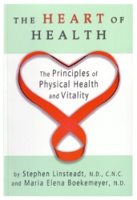



2011-06-10

